Feature image content: "Find your perfect jeweler—start now!"
Title: How to Choose the Best Diamond Jeweler in Greensboro
Focus Keyword: Diamond jewelers greensboro
Related Keywords:
greensboro jewelers
custom jewelers greensboro
best jewelry Store near me
designer jewelry

Internal link:
Best jewelry store in greensboro: https://crystaljewelersnc.com/

Word count: 1200

Meta Title:
How to Choose the Best Diamond Jeweler in Greensboro
Meta Description:
Discover 7 expert tips to find the best diamond jeweler in Greensboro. Crystal Jewelers guides you on credentials, quality, and trust to make the right decision.

How to Choose the Best Diamond Jeweler in Greensboro?
Finding the perfect jewelry is always dependent on the question on whether you buy it from the perfect diamond jeweler in Greensboro or not. A right jeweler can help you purchase a piece of jewelry that is going to tell your story. We know how big this decision is at Crystal Jewelers. Whether you’re in search of an engagement ring, a custom pendant, or timeless gift, here are 7 key pieces of advice to guide you to a jeweler who will focus on quality, transparency, and your own vision.

1. Verify Credentials & Certifications:
Always start with credentials. Well-known Diamond jewelers Greensboro will have certificates from the leaders in a particular industry, such as the Gemological Institute of America (GIA) or the American Gem Society (AGS). These certifications make gemstones ethically sourced and graded properly. In every case, when you bought diamond jewelry through Crystal Jewelers, it comes with a GIA report which outlines on cut, colour, clarity and carat. You can request proof of certification because It’s your right as a buyer.

Why It Matters?
GIA arbitrations are the industry’s gold standard because they offer an unbiased quality determination of a diamond. For instance, table depth, symmetry and fluorescence of a 1-carat round brilliant diamond certified by GIA are exact, while you are guaranteed to pay for what you see. Keep away from jewelers whose only certificate is in-house “certificates” that are never verified by a third party. We also offer AGS certification at Crystal jewelers for gem stones such as sapphire and ruby to confirm to the natural origination and the treatments.

2. Prioritize Local Expertise:
Support Greensboro jewelers that understand your community. Jewelers which operate in the local market are very helpful as they give you personalized service and they also have clearer contacts with the suppliers of the goods, and their pricing is more reasonable and the designs are unique. You can visit our store in Greensboro, where our team has been serving Greensboro for more than a decade. We’re not just sellers; we’re your neighbors concerned about your satisfaction.

Local Benefits:
Selecting a local jeweler will be reflected in reduced turnaround times on repairs and custom designs. For instance, our in-house workshop in Greensboro can resize a ring in 48 hours, while chain stores may take weeks. We also host exclusive events for locals, like diamond education workshops and trunk shows featuring designer jewelry collections. Plus, we partner with Greensboro charities, donating a portion of every sale to community initiatives.

3. Demand Transparent Pricing
Hidden fees erode trust. The best Diamond jewelers Greensboro provide clear, upfront pricing. Ask for a breakdown of costs, including stone, setting, and labor. At Crystal Jewelers, we explain every charge and even show you how metal purity (like 14K vs. 18K gold) affects price. No surprises, just honesty.

Price Transparency in Action:
A common hidden cost is the “setting fee,” which some jewelers tack on after quoting a diamond’s price. At Crystal Jewelers, our quotes include the complete cost: diamond, setting, taxes, and labor. For example, a classic solitaire engagement ring with a 0.75-carat GIA-certified diamond starts at $1,500, all-inclusive. We’ll even compare prices with competitors to prove our value.

4. Evaluate Customization Options
For truly unique pieces, choose custom jewelers Greensboro who specialize in bespoke designs. When you are going to evaluate a jeweler based on customization, you can ask different kinds of questions? Can they turn your sketch into a finished piece? Do they offer 3D modeling? Our team at Crystal Jewelers share your vision with you step by step with state of the art software modelling your ring or necklace before it is created. We’ve taken heirloom stones and turned them into modern marvels and built custom engagement rings, from the ground up, all according to your budget.

The Custom Process:
Here’s how it works:
- Consultation: Share your ideas budget and timeline.
- 3D Rendering: Our 3D representation of the model is a lifelike digital skip.
- Material Selection: Select beauty that is sourced ethically, lab-grown, or recycled metal.
- Crafting: We take 4–6 weeks to handcraft your piece by our artisans.
We turned a client’s grandmother’s emerald into a modern looking Art deco pendant with the help of a recycled platinum chain, old and new married perfectly.

5. Inspect Craftsmanship & Quality
Examine the details. Are prongs secure? Are settings polished? Greensboro's best jewelry store will display flawless craftsmanship. For instance, our solitaire rings have precision-cut diamonds set in hand finished bands, with durability and brilliance in mind. Don’t be afraid to inquire about the jeweler’s repair policies; we provide free prong tightening, annual cleanings, to save your investment.

Craftsmanship Spotlight:
Our jewelers learn for years on methods such as milgrain detailing and pavé setting. You can see example of our craftsmanship through our creation of an anniversary band of 20m. Additionally, our pavé diamonds each of which was set by hand to ensure that there are no gaps or uneven spaces. During inspections we also use microscopes to find even the microscopic flaw to guarantee that every piece of equipment is up to our high standards.

6. Read Reviews & Testimonials
What do others say? Check Google, Yelp, and social media for feedback on Diamond jewelers Greensboro. Check out regular praise regarding service, quality, and after sales support. Crystal Jewelers is proud to have a 5-star rating across platforms, where clients speak of our patience, expertise and smooth custom design process.
Real Client Stories:
- Sarah T.: “Crystal Jewelers redesigned my mom’s broken bracelet into a stunning necklace. Their team listened to every detail!”
- James R.: “They helped me surprise my fiancée with a custom ring that matched her vision perfectly. No other best jewelry store near me compares.”

7. Visit the Store For Seamless Experience
A “best jewelry store near me” should be welcoming. Book an appointment to check how seamless it is, the employee’s knowledge, and variety of inventory. At Crystal Jewelers, our Greensboro showroom has private consultation rooms where you can explore designs at your own pace. Practice on designer jewelry storages, compare sizes of the diamonds and check what different metals will look like on your skin tone.
In-Store Perks:
- Virtual Try-On: Our AR mirror allows you to “wear” necklaces or earrings.
- Trade-In Program: Improve your old jewelry by using fair-value credit for new purchases.
- Financing: Flexible repayment plans with With Snap and get Up to $5,000 approval.

Why Choose Crystal Jewelers?
We’re not just a display case for fine jewelry, we’re your partners in creating priceless memories. Here’s why Greensboro trusts us:
- Ethical Sourcing: All diamonds in our collection are conflict free with blockchain-tracked origins from mine to market.
- Unmatched Craftsmanship: Each of our pieces is produced by our artisans, who have attended Europe’s best workshops.
- Transparency: Education guides for free diamonds, and monthly Q&A’s are also hosted by us.
- Custom Excellence: As Greensboro, leading custom jewelers, we’ve been awarded for innovative designs, like also being our “Twist” engagement ring collection.
Check us now out to see our selected designer jewelry from different brands or start your own custom design. Our lifetime guarantee on all our jewelry includes that on resizing, rhodium plating and tightening stones since your jewellery should grow with you.

Ready to Discover Brilliance?
Visit Crystal Jewelers, the best jewelry store in Greensboro or set up an appointment online. During this period, you will get a free jewel cleaning kit with purchase!. Together, using our knowledge and your imagination, we’ll create a diamond piece that will shine for centuries. The journey of perfectly crafted jewelry begins with you at the place where quality and heart meet.
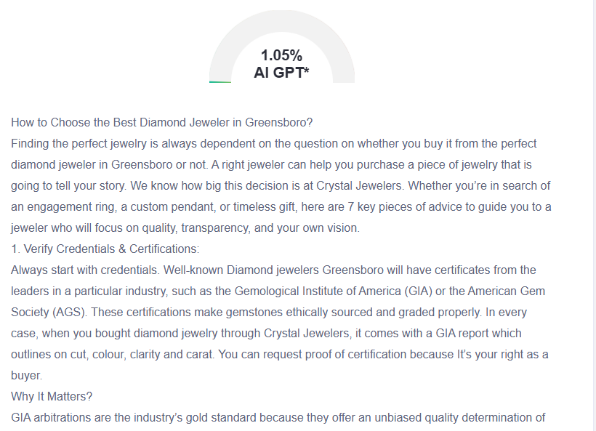

GMB
Crystal Jewelers help you find jewelry that will tell your story. We are proud to offer a decade of experience and the country’s two top certifications (GIA and AGS) to Greensboro’s jewelry scene, assuring you of quality. All our diamonds have detailed GIA reports on cut, color, clarity, and carat. Our pricing is transparent and will not surprise you with hidden fees. Our team is excellent in custom pieces through our step by step design process. With 3D modeling and competent craftsmanship, we bring your ideas to the reality. We make heirloom redesigns and we build engagement rings from scratch. Our in-house workshop produces both repairs and resizing within 48 hours. We do not only pay attention to the polished settings; we also mind the placement of the stones; secure prongs, polished settings, and precise stone placement. We offer free prong tightening and annual cleanings to protect your valuable purchase. Our showroom has personal consultation areas, a try-on area via AR mirror and trade in for your old jewellery. The diamonds we source have conflict free origins with origins tracked with blockchain. We organize monthly Q&As, and offer free diamond education guides. We back all our pieces with a lifetime guarantee for resizing, rhodium plating and stone tightening. Come to our store or reserve an appointment of your convenience to enjoy jewelry shopping as you deserve. We're more than jewelers; we are your partners in crafting valuable works that radiate for hundreds of years.

